Supplementary Detail (SD) S1. Data collection
For the mapping activity, fishers were provided with an A2 paper admiralty chart of the Western Indian Ocean, with land areas and latitude and longitude clearly demarcated (as shown in the image below).
Fishers were asked to then either draw shapes (polygons) or provide coordinates for every area they considered to be of importance to their fishing activity. For each area, they were asked to provide corresponding estimates of the following information:
- Economic contribution of each area (% contribution of polygon to vessel total annual earnings, averaged over the last 5 years);
- Species targeted (% contribution of ≤3 main species to earnings of polygon).
Researchers reviewed the maps during the interview to ensure data was complete, including checking total percentages, before asking fishers to review them to ensure they were happy.
Table S1. Summary of data collected from fishers during interview and mapping exercise. Specific questions asked of fishers is also included.
Type | Category | Question posed | Question type | Data type
Fisher characteristics | Experience | How long have you been a multi-day fisher? | Open-ended | Years (continuous)
 | Reliance | What % of your annual income comes from fishing? | Open-ended | % (continuous)
 | Income satisfaction | How satisfied are you with your level of income? | Closed | Likert-scale (from “extremely satisfied” to “extremely dissatisfied”) (categorical)
Vessel Characteristics | Gear type | What are your 2 main fishing gears? (Rank from 1-2 in terms of importance) | Open-ended | Coded to five categories (categorical)
 | Vessel size | How big is your vessel? | Open-ended | Metres (continuous)
 | Home port fidelity | What is your home port? Do you always land there? | Open-ended | Port name (s) (categorical)
 | Crew number | How many crew work full-time on board your vessel? | Open-ended | Persons (continuous)
 | Licensing | Does your vessel hold a high seas licence? | Closed | Yes/No (binary)
 | Equipment | Which tracking equipment do you have on-board your vessel? | Closed | Coded to four categories (categorical)
Fishing Characteristics | Target species assemblage | What are your 3 main target species (Rank from 1-3 in terms of importance) | Open-ended | Coded to five categories (categorical)
 | Species importance | For each polygon, please give your three most important species and their contribution (%) to annual catch catch worth ($) | Open-ended | Species name and % (spatial)
 | Shark reliance | Do you target sharks?  What % of your annual incomes comes from fishing for sharks? | Closed: Open-ended | Yes/No (binary): % (continuous)
 | Percentage earnings | For each polygon, please give an estimate for annual contribution (%) to total annual catch worth ($) | Open-ended | % (continuous, spatial)
 | Fishing trip | How many days are your fishing trips, on average?  How many trips do you do per year, on average? | Open-ended | Days: Trip no. (continuous)
 | Vessel earnings | How much is your catch worth per trip, on average?  What are your total costs per trip, on average? | Open-ended | $ (continuous)
Fisher perceptions | Closed areas | I think closing areas to fishing can help increase fish populations? | Closed | Likert-scale (categorical)
 | Non-compliance | Have you ever been fishing in other countries waters;  - over the last 12 months  - 5 years | Closed | Yes/No (binary)
 |  | What is your chance of getting caught whilst conducting these activities | Open-ended | % (continuous)
 | Non-compliance of others | In your opinion, what % of skippers from your home port have fished in other countries waters;  - over the last 12 months  - 5 years | Closed | 0-20%, 21-40%, 41-60%, 61-80%, 81-100% (categorical)
 |  | In your opinion, why do some people risk fishing in other countries waters? | Open-ended | Coded against thematic analysis framework

Supplementary Detail (SD) S2. Methodological considerations
Due to the sensitive nature of the topics discussed during interviews, facilitators used a “scoring system” of honesty and willingness (1-10; 1 being not honest/willing at all and 10 being entirely honest and eager to help). A separate box was also included on forms for facilitators to record notes on issues that may have introduced bias. Subsequently, the lead author excluded data from both mapping and interviews when fishers expressed strong uncertainty about their knowledge, or indicated dishonesty. A total of five data records were excluded. This data was also analysed to interpret accuracy of rates, e.g. of illegal activity. Findings suggest that accuracy may be compromised by both non-response and social desirability bias to a degree. For example, five fishers said they were unwilling to provide some of their fishing areas as they were illegal and some fishers said they had omitted some areas they didn’t want to disclose. In order to address issues of bias, cross-method triangulation was included in our methodology, where data from different methods were used not to compare results but to deepen our understanding of the issues (Bennett, Roth, Klain, K. Chan, et al., 2017). This can be particularly useful in situations where illicit, sensitive issues are being discussed (Bryman, 2016; Travers et al., 2019). Additional research would help to identify the accuracy of our findings regarding magnitude of non-compliance.
Supplementary Detail (SD) S3. Data processing
A shapefile (map) was created for each individual vessel, comprising of multiple polygons, and joined to corresponding attribute data taken from interviews and mapping activities. The figure below shows all fishing areas (polygons) provided by sampled vessels. Where fishers provided point (coordinate) fishing areas, these were created as a buffered polygon of a standardised size. Buffer size was equivalent to~850km² and was chosen following discussions with fishers about the typical size of fishing areas.
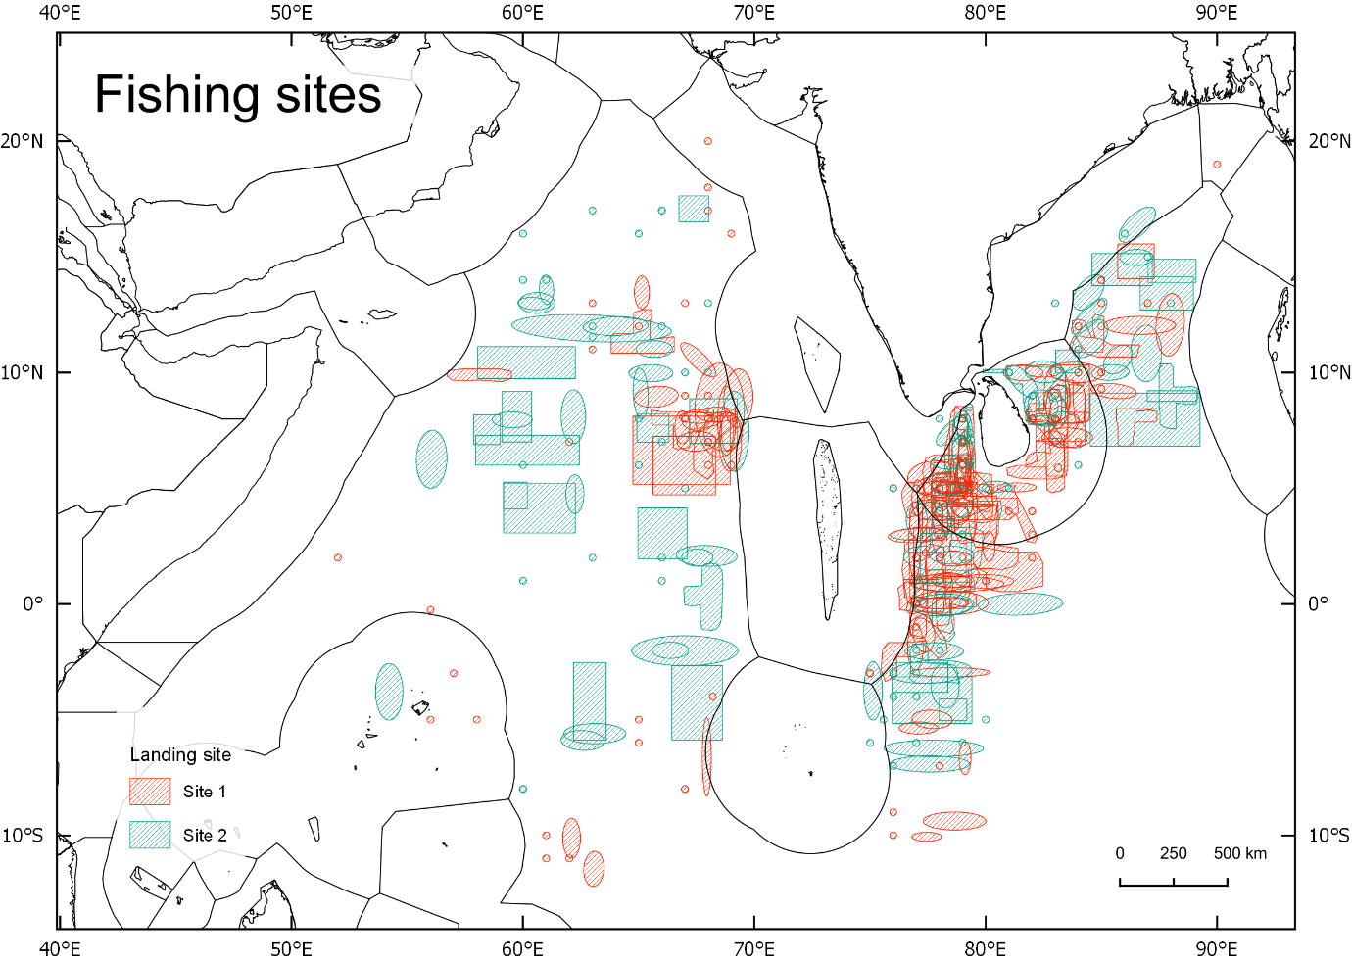
Map of all polygons provided by fishers during the participatory mapping exercise. Colour indicates normal landing site (Site 1 in red and Site 2 in blue).
Attribute data was created by coding and categorising answers, including creation of dummy variables. Data categories were created following a review of all potential answers and categories were given dummy numerical values. For example, we reviewed all potential species combinations across all vessels and created unique categories for each answer. This dataset was linked to the individual shapefiles by joining the attribute table within QGIS.
All shapefiles were then merged to create a master shapefile which contained all polygons and linked attribute data. A polygon grid overlay was then applied to this master shapefile. Grid size (~2,500km²) was chosen as a trade-off between spatial accuracy, visualisation and number of eventual datapoints. In order to obtain gridded dataset, the original polygons were intersected, resulting in smaller polygons cut at the grid edges. Values were then summarised (including sum and average values) on per grid. Note that a buffer was created around the original grid before joining occurred, in order to ensure only values contained (and not intersected) with grids were calculated. For both the polygon and grid dataset overlap with different areas of spatial jurisdiction were calculated using overlap analysis tool.

Supplementary Detail (SD) S4. Variable selection
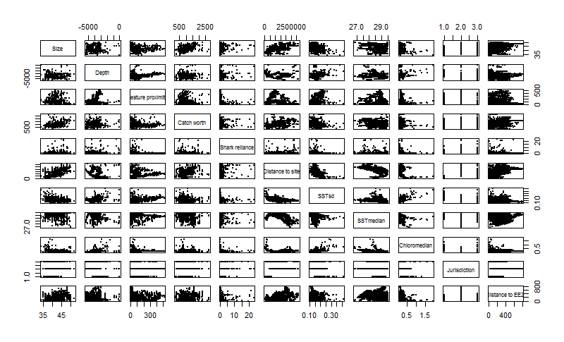
Figure S4.1 Correlation scatterplots to show relationship for all possible variable pairs.
Table S4.1 Correlation coefficient matrix between all possible variable pairs. Boxes are shaded grey to indicate strong correlation between pairs (>0.6).
 | Size | Depth | Feature proximity | Catch worth | Shark reliance | Distance to site | SST  sd | SST  median | Chloro  median
Size | 1 | 0.2 | -0.4 | 0.67 | 0.11 | 0.66 | -0.36 | -0.22 | -0.05
Depth | 0.2 | 1 | -0.05 | 0.1 | -0.13 | 0.04 | 0.23 | -0.18 | 0.38
Feature proximity | -0.4 | -0.05 | 1 | -0.38 | -0.17 | -0.52 | 0.5 | -0.06 | 0.23
Catch worth | 0.67 | 0.1 | -0.38 | 1 | 0.11 | 0.5 | -0.25 | -0.14 | -0.06
Shark reliance | 0.11 | -0.13 | -0.17 | 0.11 | 1 | 0.18 | -0.07 | -0.12 | -0.16
Distance to site | 0.66 | 0.04 | -0.52 | 0.5 | 0.18 | 1 | -0.49 | -0.5 | -0.09
SST (sd) | -0.36 | 0.23 | 0.5 | -0.25 | -0.07 | -0.49 | 1 | -0.24 | 0.25
SST (median) | -0.22 | -0.18 | -0.06 | -0.14 | -0.12 | -0.5 | -0.24 | 1 | -0.5
Chloro (median) | -0.05 | 0.38 | 0.23 | -0.06 | -0.16 | -0.09 | 0.25 | -0.5 | 1
Jurisdiction | 0.13 | 0 | -0.11 | 0.07 | -0.03 | 0.33 | -0.26 | -0.04 | -0.25
Distance to EEZ | 0.44 | -0.04 | -0.21 | 0.36 | -0.07 | 0.5 | -0.29 | -0.17 | -0.01

Table S4.2. Variance Inflation Factors (VIF) for all variables
Variables | VIF | 1/VIF | VIF (with vessel size not incl.) | 1/VIF (with vessel size not incl.) | VIF (- distance to EEZ) | 1/VIF (-distance to EEZ)
Size | 2.54 | 1.59 | Not included | Not included | Not included | Not included
Depth | 1.52 | 1.23 | 1.48 | 1.19 | 1.46 | 1.21
Feature proximity | 2.21 | 1.49 | 2.2 | 1.22 | 2.16 | 1.47
Distance to site | 8.49 | 2.91 | 7.69 | 1.48 | 6.07 | 2.46
SST (sd) | 2.44 | 1.56 | 2.43 | 2.77 | 2.43 | 1.56
SST (median) | 4.24 | 2.06 | 4.17 | 1.56 | 3.81 | 1.95
Chlorophyll a (median) | 2.39 | 1.55 | 2.39 | 2.04 | 2.32 | 1.52
Jurisdiction | 2.96 | 1.31 | 2.89 | 1.55 | 2.31 | 1.23
Catch worth | 1.78 | 1.33 | 1.5 | 1.3 | 1.42 | 1.19
Shark reliance | 1.51 | 1.23 | 1.87 | 1.22 | 1.46 | 1.21
Distance to EEZ | 1.87 | 1.37 | 1.48 | 1.37 | Not included | Not included

Figure S1 Exemplar of social explanatory variables used in geospatial Generalised Linear Models, per grid cell. Average catch worth per unit effort (1% of annual fishing effort, per vessel) ($) (A), average reliance on sharks for annual fishing effort (%) (B), average cost per unit effort (1% of annual fishing effort, per vessel) ($) (C), average vessel size (metres) (D).
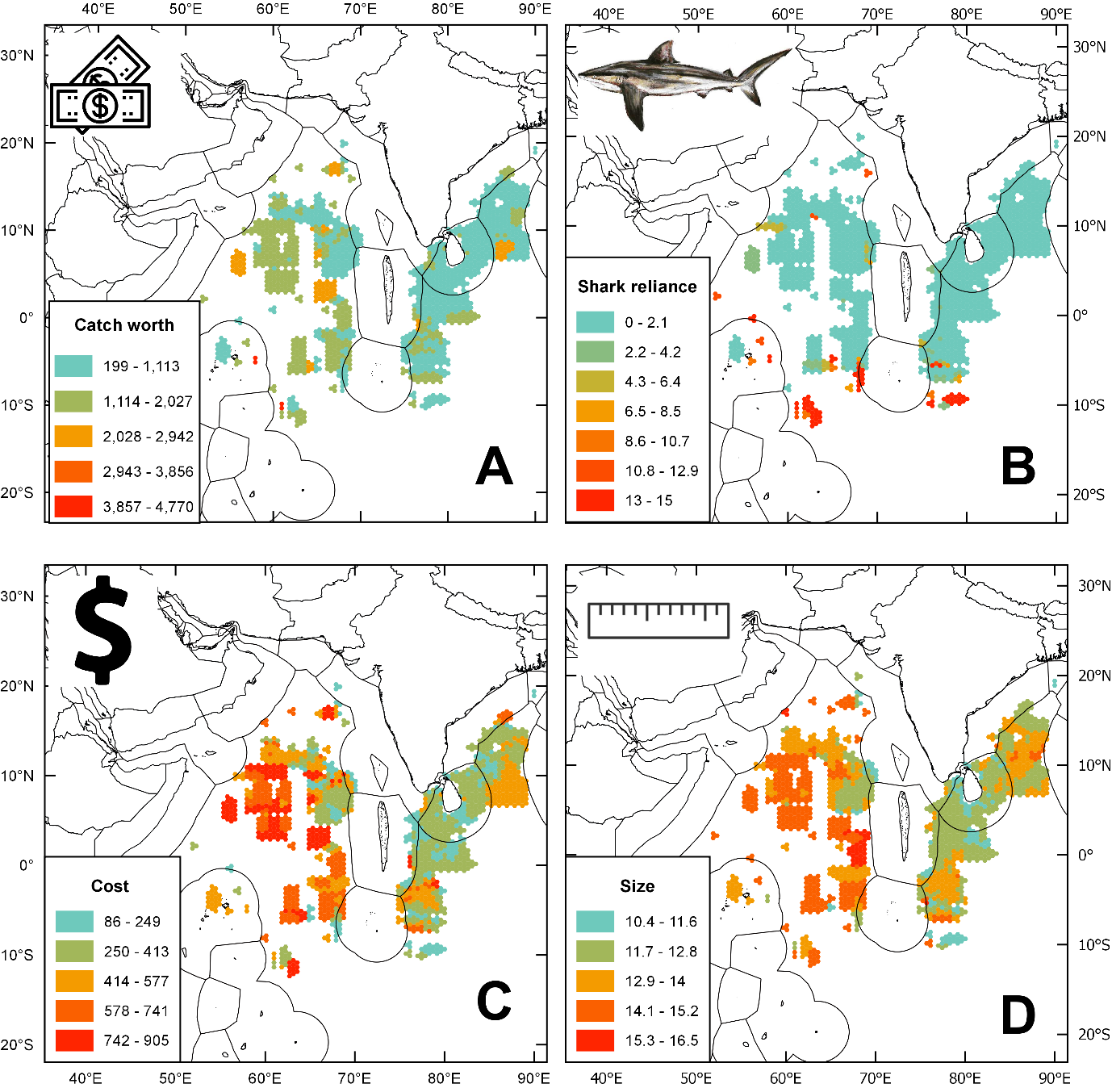
Figure S2. Distribution of response variable (fishing days per grid cell), showing a positive-skewed distribution
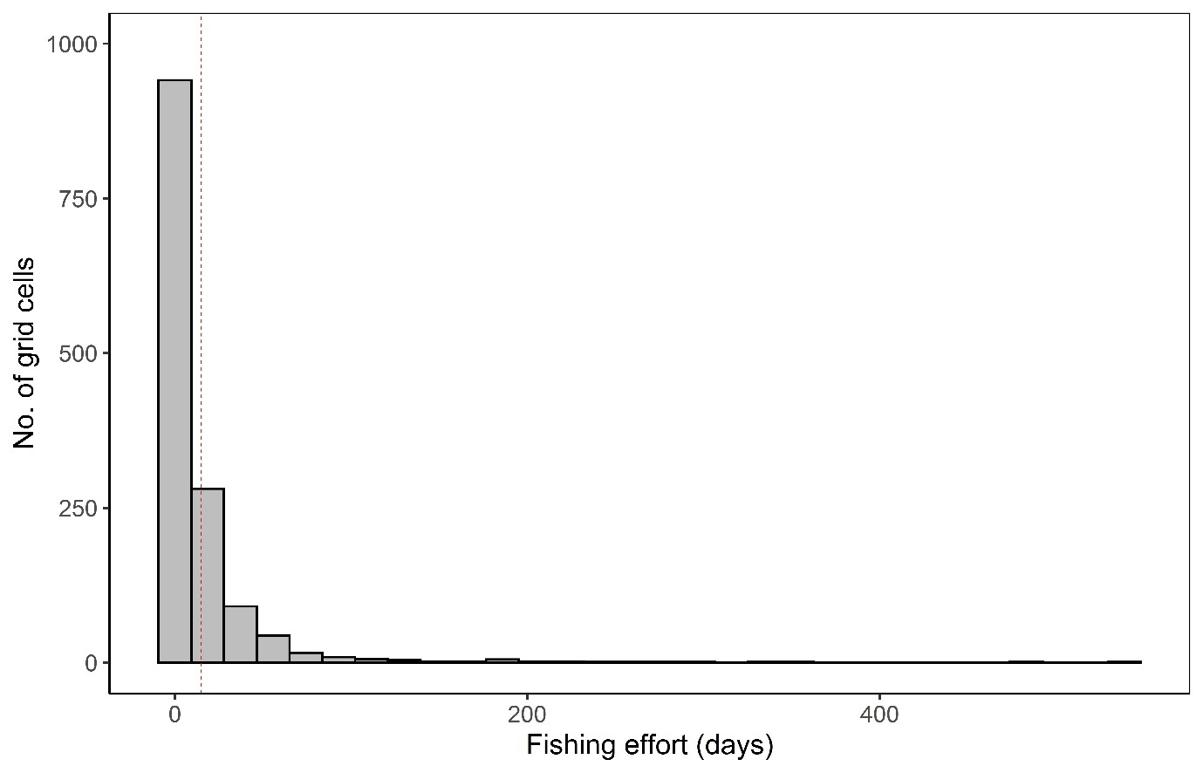
Table S3. Generalised Linear Models ranking results. Comparison of candidate models predicting fishing effort (days) as a function of social, environmental and spatial management explanatory variables, based on Akaike’s Information Criteria corrected for small samples (AICc). Nul model is shown for reference. LL: Maximum Log Likelihood, df: degrees of freedom, Δ_{m} : delta score for each model and %DE: percentage of deviance explained. Model with best fit highlighted in bold. Catch Worth Per Unit Effort (CWPUE), Distance = Distance from landing sites, Sea Surface Temperature (SST), Residual AutoCovariate (RAC)
Model | LL | df | AICc | Δ_{m} | %DE
Model adjusted for spatial autocorrelation: Days ~ Distance to landing sites + Shark reliance + Catch Worth + SST (median) + SST (sd) + Depth + Distance to features + RAC | -4461.8 | 10 | 8943.7 | n/a | 36%
Best: Days ~ Distance to landing sites + Shark reliance+ Catch Worth + SST (median) + SST (sd) + Depth + Distance to features | -4619.1 | 9 | 9256.4 | 0 | 24%
2: Days ~ Distance to landing sites + Shark reliance + Catch Worth + SST (median) + SST (sd) + Depth + Distance to features + Chlorophyll a (median) | -4618.3 | 10 | 9256.7 | 0.3 | 19%
Nul: Days ~ 1 | -4867 | 2 | 9738.5 | -428.1 | 0%

Figure S3. Contribution of target species assemblage and gear type to annual fleet profits (y); A= Tuna (1), Billfish (2), Sharks/Rays/Carangidae/NA (3). B=Tuna (1), Shark (2) Billfish/NA (3), C=Others (1), Tuna (2), Billfish (3), D=Sharks (1), Tuna/Billfish/NA (2) and E= Tuna (1), Carangidae (2) Billfish (3). Fill is gear type, relative importance shown in brackets.
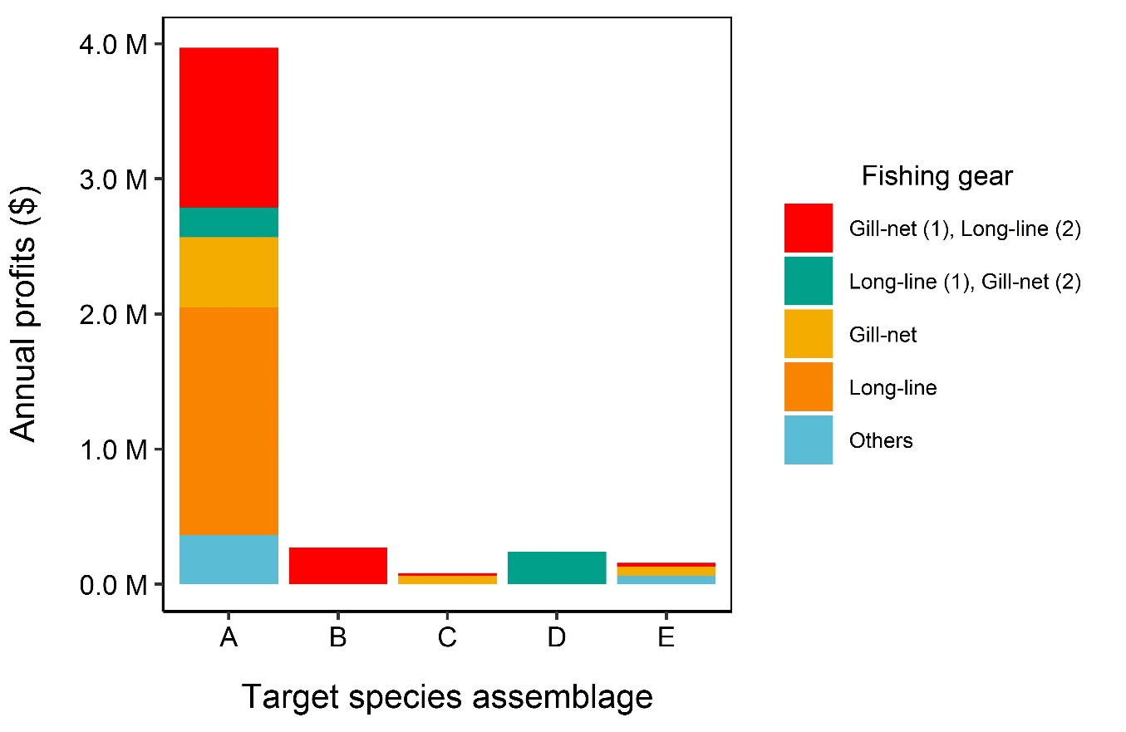
Supplementary Detail (SD) S5. Modelling non-compliance
Table of selected explanatory variables based on data exploration and key relevant literature analysis used in modelling of non-compliance (binary response)
Name | Description | Source
Risk | Fishers were asked what the chances of being arrested whilst fishing in prohibited areas (%) | Interview data
Descriptive norms | Fishers were asked to describe how many other vessels within their landing site (registered) engage in fishing in prohibited areas (0-20; 21-40; 41-60; 61-80; 81-100%)
Own rate of IUU | Fishers were asked whether they had personally engaged in illegal activity during the last five years (Yes: No)
Vessel costs | Annual costs of running vessels were calculated using average cost of fishing trips multiplied by average number of fishing trips. This includes fuel, ice and food (LKR/$)
Catch worth | Annual catch worth of vessels were calculated using average worth of catch per fishing trips multiplied by average number of fishing trips (LKR/$)
Size | Vessel size (feet/metres)
HSL | Fishers were asked whether their vessel was in possession of a High Seas Licence (Yes: No)
Equipment | Surveillance equipment (functioning)
Landing Site | Landing site of sampled vessels
Reliance on sharks | Proportion of annual fishing effort for sharks | Mapping activity

Once variables were chosen, data exploration was conducted as described for Model 1 (Zuur, Ieno and Elphick, 2010). A binary response variable of whether fishers engaged in IUU or not was chosen as the rv (Yes/No). Fishers who had indicated, during the mapping activity, that they fished in FEEZs for > 0.01% of annual fishing effort were classified as non-compliant (Yes). GLMs with a binomial family and “logit” link function were chosen, and stepwise backwards regression was utilised to select a best-fit model using the AICc score criterion. Results are presented in table below.
Table of comparison of candidate models predicting non-compliance (Yes/No) as a function of social explanatory variables, based on Akaike’s Information Criteria corrected for small samples (AICc). Null model is shown for reference. LL: Maximum Log Likelihood, df: degrees of freedom, Δ_{m}: delta score for each model and %DE: percentage of deviance explained. Model with best fit highlighted in bold.
Model | LL | df | AICc | Δ_{m} | %DE
Best: Non-compliance ~ Perception of others engaging in IUU + Non-compliance from interview + Size | -53.7 | 4 | 115.8 | 0 | 8%
Non-compliance ~ Catch worth + Perception of others engaging in IUU + Non-compliance from interview | -53.9 | 4 | 116.4 | 0.6 | 7%
Non-compliance ~ Perception of others engaging in IUU + Non-compliance from interview | -55.1 | 3 | 116.6 | 0.7 | 5%
Nul model: Non-compliance ~ 1 | -58 | 1 | 118.5 | n/a | 0%

The best model (lowest AICc score=115) explained 8% of the deviance in compliance. No variable had a significant effect on whether fishers were compliant or not. Fishers answer to direct questioning about non-compliance during interviews was the most important variable, accounting for 3.5% of deviance and increasing likelihood of non-compliance. Secondly, fishers’ answers as to whether other vessels engaged in non-compliance within their port had a negative effect, accounting for 3% of deviance. Lastly, size accounted for 1.5% of deviance, with smaller vessels more likely to engage in non-compliance. No variables had a significant effect.
Figure S4. Total effort (% of annual fleet fishing effort) and catch worth (% of all annual fleet catch worth) separated by spatial jurisdiction of fishing area.
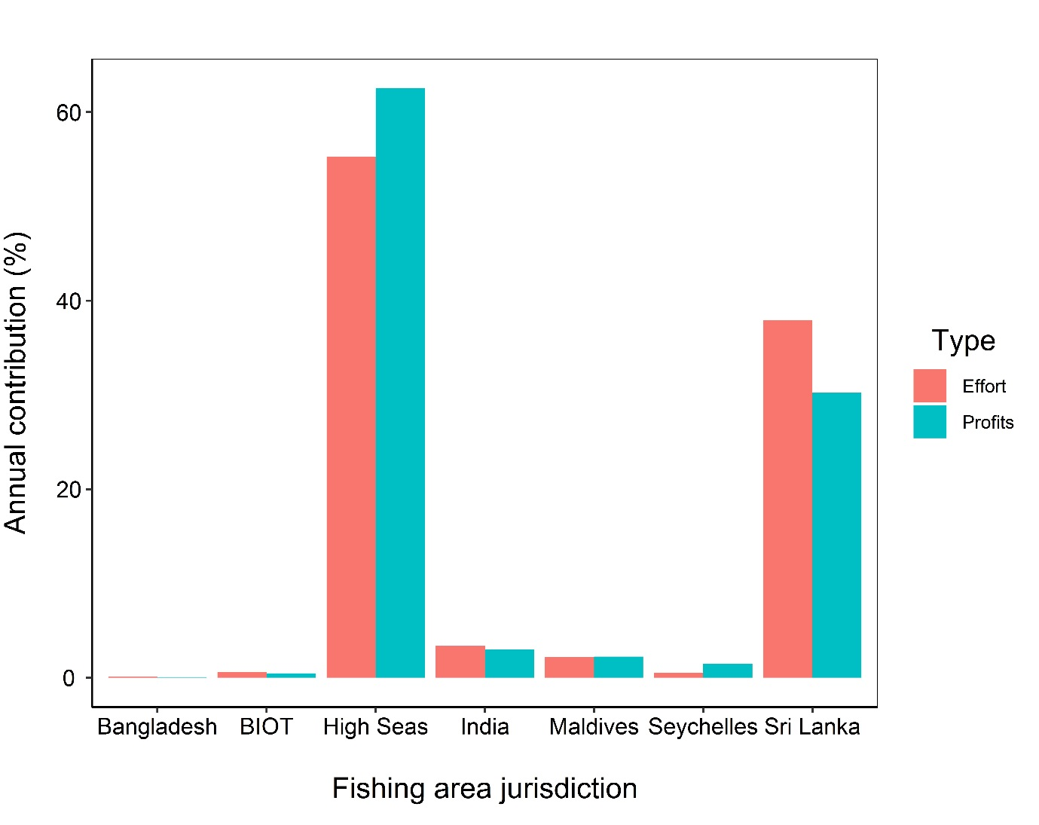

Figure S5 Relative influence of explanatory variables assessed using the weighted Akaike Information Criterion (AICw) from an analysis of all possible GLMs modelling spatial distribution of fishing effort

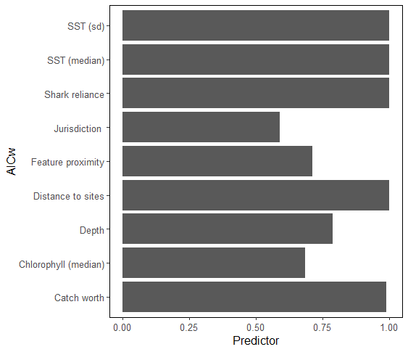

Figure S6. Fisher responses to direct questioning during interviews regarding whether they had fished in foreign waters in the last five years (top), and in the last year (bottom). Their perception of proportion (%) of other fishers in their port who have fished in foreign waters over the same time period is represented (fill).
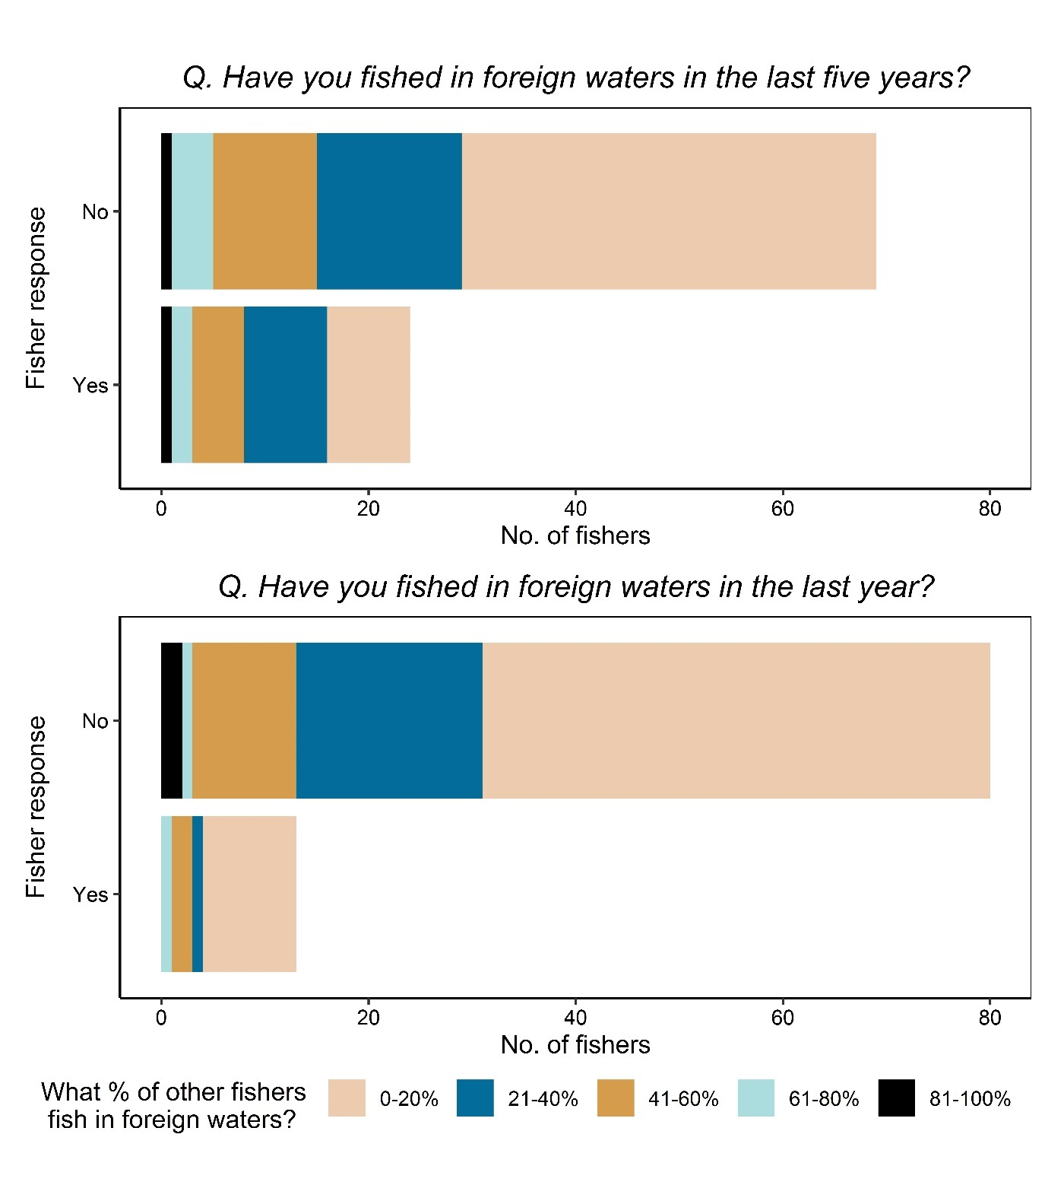

Figure S7. Dendrogram showing the four clusters generated using Hierarchical Cluster Analysis. For each cluster, an associated label and percentage of non-compliance are shown. The height corresponds to the increase within-cluster computed in Ward's method.

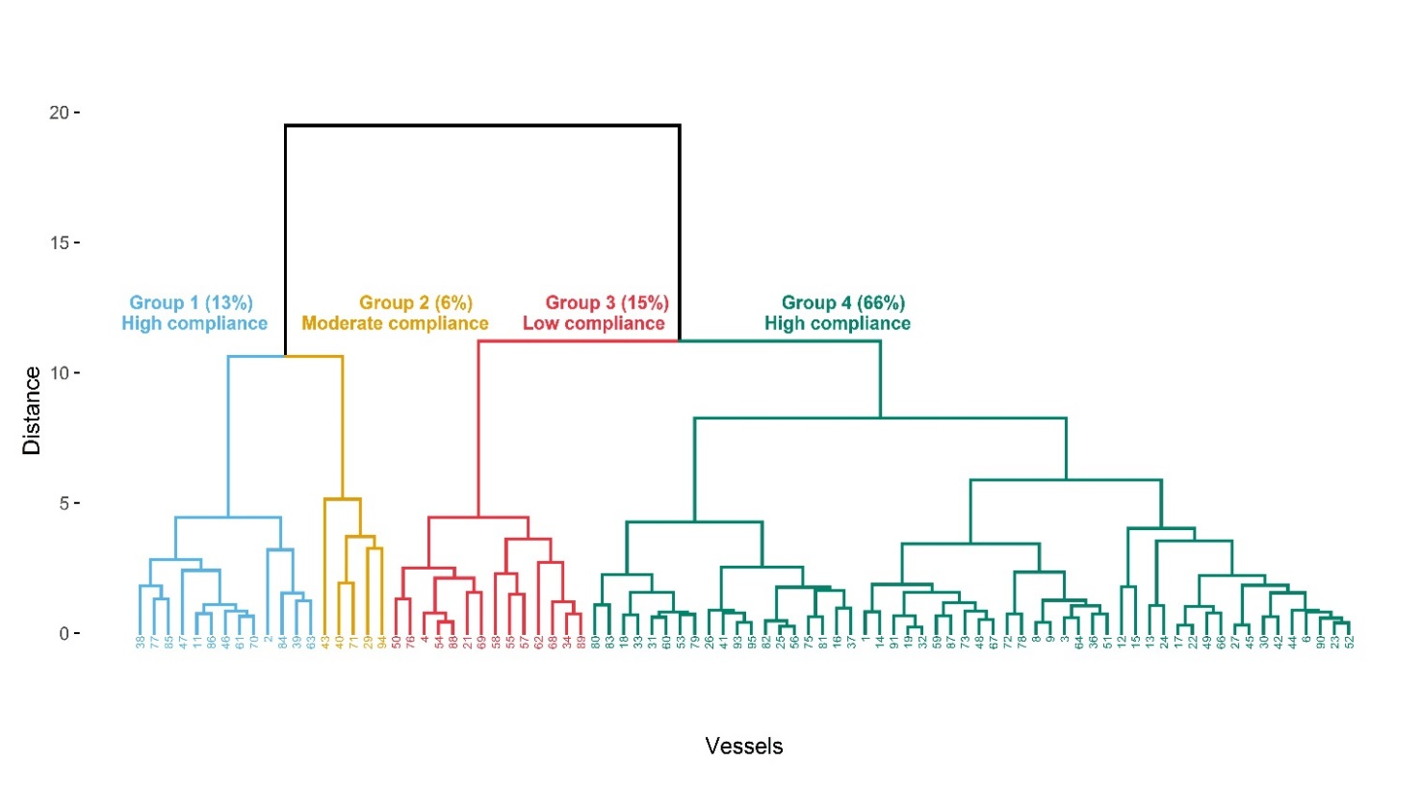

Figure S8 Boxplots to demonstrate variability of characteristics shared by vessels organised into four clusters using Hierarchical Cluster Analysis. Medians are represented by the line within each box and means are indicated by black circles.
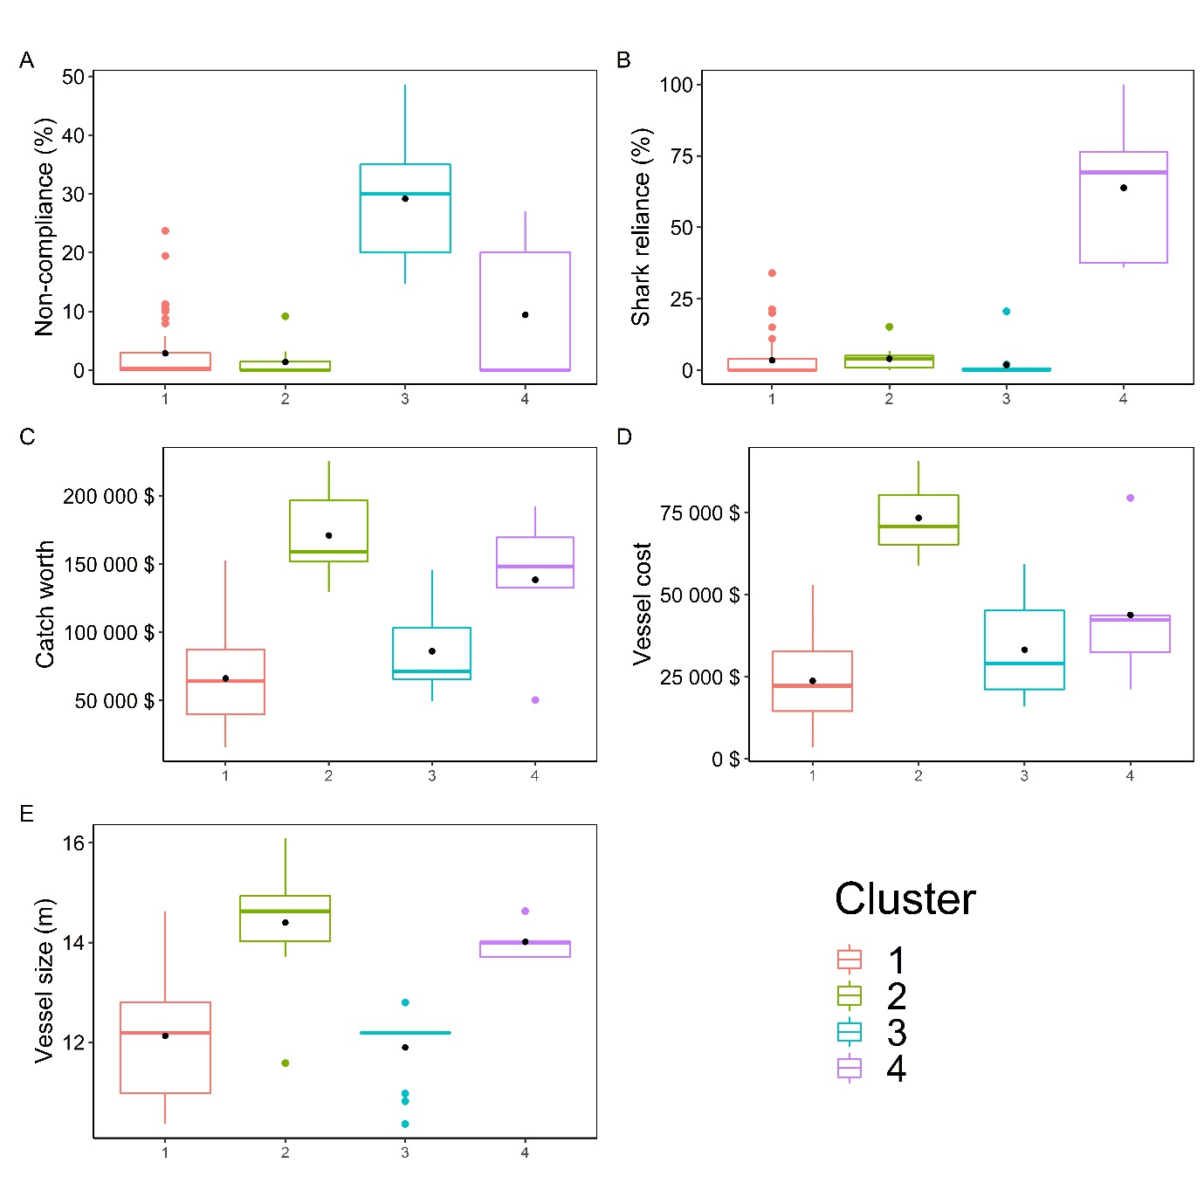

Figure S9. Combined boxplot and violin plot to demonstrate coverage of vessel equipment (taken from interview data) against level of non-compliance (expressed as % of annual fishing effort expended in foreign countries waters) (taken from mapping exercise).
