Abstract.—lncidental kills of marine mammals, turtles, and seabirds are estimated for the California drift gillnet fishery for broadbill swordfish, Xiph i.as gladius, common thresher shark, Alopias vulpinus, and shortfin mako shark, Isurus oxyrinchus, and the set gillnet fishery for California halibut, Paralichthys californicus, and Pacific angel shark, Squatina californica. for the period July 1990 through December 1995. Estimates were based on observations made by National Marine Fisheries Service observers placed aboard commercial fishing vessels. Yearly observer coverage varied between 4% and 18% of estimated total effort. 'Ibtal fishing effort-days per California Department of Fish and Game fishing block was used as the measure of effort for the drift and set gillnet fisheries. Incidental kill was estimated from observed data and estimates of total effort by using mean-per-unit and ratio estimators. Additional bycatch data collected by NMFS observers were used to derive kill estimates of marine turtles and seabirds.
In the drift gillnet fishery, seven out of 387 mammals observed entangled were released alive. In the set gillnet fishery, five out of 1,263 mammals observed entangled were released alive. Estimates of incidental kill are presented along with estimates of entanglement for species that were observed to be released alive. For the period under consideration, the estimated mortality for the drift gillnet fishery was over 450 marine mammals each year. A total of 20 turtles and 3 seabirds were observed entangled during the entire period. The most frequently entangled species in this fishery were common dolphins, Delphinus spp., and northern elephant seals, Mirounga angustirostris. Estimated cetacean mortality in the driftnet fishery decreased from 650 in 1991 to 417 in 1995: pinniped mortality decreased from 173 in 1991 to 116 in 1995. Estimated cetacean mortality in the set gillnet fishery ranged from a high of 38 in 1991 to a low 14 in 1993; pinniped mortality rose to a high of4,777 in 1992 and then decreased to 1,016 in 1995. We postulate that there has been a decline in the number of pinnipeds and cetaceans in the setnet fishery owing to area closure. No similar proposal can be made for the driftnet fishery. The most frequently entangled mammals in the setnet fishery were California sea lions, Zal.ophus californianus, and harbor seals, Phoca vituli.na. Six turtles and 1,018 seabirds were estimated entangled in this fishery during the NMFS Observer Program from July 1990 to December 1995.
Manuscript accepted 25 June 1997. Fishery Bulletin 96:271-284 (1998).
Estimates of marine mammal, turtle, and seabird mortality for two California gillnet fisheries: 1990—1995

Fred Julian
142 Sierra way
Chula Vista, California 9191 1
E-mail address: fjulian@osiris.ucsd.edu

Marilyn Beeson
California Department of Fish and Game 330 Golden Shore, Suite 50
Long Beach, California 90802

Two major gillnet fisheries in California are known to kill marine mammals, turtles, and seabirds incidentally: the drift gillnet fishery for broadbill swordfish, Xiphias gladius, common thresher shark, Aopias vulpinus, and shortfin mako shark, Isurus oxyrinchus, and the set gillnet fishery for California halibut, Paradichthys californicus, and Pacific angel shark, Squatina californica. Historically, concern was focused on incidental kill of seabirds, sea otters, Enhydra lutris harbor porpoise, Phocoena phocoena , harbor seals, Phoca vitulina, and California sea lions, Zalophus californianus, in the setnet fishery (Salzman, 1989; Jefferson et al., 1994; Diamond and Hanan ^{l} ; Hanan et al. ²'³ ; Hanan and Diamond⁴ ). In recent years the driftnet fishery has received more attention because it interacts with more cetaceans (Barlow et al., 1994; Lennert et al., 1994). Estimation for the driftnet fishery has been possible because, in July 1990, the National Marine Fisheries Service (NMFS) implemented an observer program to monitor the marine mammal bycatch. Complementing the observer program was a project by the California Department of Fish and | Game (CDFG) to develop estimates of total effort in the drift and set gillnet fisheries. Results from these programs were used to estimate incidental kill with stratified ratio and mean-per-unit estimation  - Diamond, S. L., and D. A. Hanan. 1986. An estimate of harbor porpoise mortality in California set net fisheries, April 1. 1983 through March 31, 1984. NOAA/NMFS SWRAdmin. Rep. SWR-86-15, 40 p. [Available from Southwest Fisheries Science Center, National Marine Fisheries Service, P.O. Box 271, La Jolla, CA 92038.]  - Hanan. D. A., S. L. Diamond, and J. P. Scholl. 1986. An estimate of harbor porpoise mortality in California set net fisheries, April 1, 1984 through March 31, 1985. NOAA/NMFS SWR Admin. Rep. SWR-86-16, 38p. [Available from Southwest Fisheries Science Center, National Marine Fisheries Service, P.O. Box 271, La  Jolla. CA 92038.]  - Hanan, D. A., S. L. Diamond, and J. P. Scholl. 1988. Estimates of sea lion and harbor seal mortalities in California set net fisheries for 1983, 1984, and 1985. Final Rep. NA-86-ABH00018 submitted to NOAA Fisheries, SWR. 10 p. [Available from Southwest Fisheries Science Center, National Marine Fisheries Service, P.O. Box 271, La Jolla, CA 92038.]  - Hanan, D. A., and S. L. Diamond. 1989. Estimates of sea lion, harbor seal, and harbor porpoise mortalities in California set net fisheries for the 1986—87 fishing year. Final Rep. NA-86-ABH00018 submitted to NOAA Fisheries, SWR, 10 p. [Available from Southwest Fisheries Science Center, National Marine Fisheries Service, P.O. Box 271, La Jolla, CA 92038.]
methods (Lennert et al., 1994; Perkins et al. ; Julian' ' ). Separate estimates of entanglement are provided for species that had individuals released alive. This paper documents incidental marine mammal, turtle, and seabird kill estimates in these two California gillnet fisheries, based on data from the NMFS observer program and CDFG effort estimates for the period July 1990 through December 1994, and documents the process and methods leading to these estimates.

Methods
Data collection
National Marine Fisheries Service observer data, daily logbooks of commercial gillnet fishermen, and receipts of landed fish sales were used in marine mammal mortality estimation. NMFS observer data were collected by trained technicians aboard commercial gillnet fishing boats that had a Marine Mammal Protection Act (MMPA) Exemption Permit and that met minimum U.S. Coast Guard safety standards. There were two general observation categories: observation of randomly selected trips and observation of approximately every fifth vessel trip. In the setnet fishery, systematically selected trips were further divided. Notification prior to the setting of nets resulted in a preset, systematic observation rather than a postset, systematic observation where notification to the vessel was given after the nets were set (see "Discussion" section). NMFS observers recorded data on location, date, marine mammal entanglements, including location of mammals in the net ( by thirds of the net—vertically and horizontally), gear, bycatch, and target species catch for each net pull observed during a trip (Lennert et al., 1994).
Observers recorded twelve net-related parameters for drift and set nets. They were net type (set, drift, float, or trammel), net material (monofilament, multifilament, or a combination), net strength (pounds test or twine size depending on strength code), strength code, net length (fathoms), net depth (number of meshes), stretched mesh size (inches), extender length (feet, float, and drift nets only), hanging line material (synthetic or natural fiber), percent slack in net, number of meshes hanging (between knots to the cork line), and hanging length ( distance between knots on the cork line in inches). Not infrequently, a drift or set net will consist of panels of varying characteristics. In this case, observers would record characteristics on up to 5 different panels. Net characteristics for both fisheries are summarized in 'Ibble 1. Although the variability in these characteristics contributes somewhat to the variability in mortality estimates, the significant factors for mortality estimation are the amount of effort and the general location of the effort. For some species, e.g. pinnipeds, quarter of the year is also significant (Perkins et al.⁵ ).
Collected data were entered into a database file, checked for accuracy, and tabulated for mortality estimation (Tables 2—5). After an initial six month period, this observation method continued unchanged in both fisheries. Realized observation rates varied between 4.4% and 17.9% yearly, but observation rates were more variable if stratified by area and quarter. Observation in the driftnet fishery continued through December 1995, whereas observation in the setnet fishery terminated by July 1994 because of a significant decrease in fishing effort in that fishery (due to regulations that restricted areas open to gillnet fishing). Observer data were complemented by information from vessel logbooks and landing receipts (i.e. receipts from sales of landed fish).
Vessel logbooks were submitted monthly to CDFG and constituted the major source of information for estimation of total effort. Data for each logbook entry included date, vessel and permit identification, area fished by CDFG block number (Lennert et al. 1994), gear, number of sets made, and number and species offish caught (CDFG blocks are typically 10' square; larger blocks are defined for areas further from shore Logbook information was entered into a database by technicians and checked for accuracy by biologists. Fish species targeted for catch by the fishermen were determined and assigned to each data entry by CDFG personnel according to fish caught, gear used, and other pertinent factors. Purchases of landed fish by commercial fish buyers were recorded and those records were submitted to CDFG twice monthly. Landing receipts included information on species landed, weight by species, price, gear, area fished, and vessel and permit identification. Landing information was entered into a database and checked for accuracy. A target fish species was assigned to each entry. Logbook data, landing information, and NMFS observer data (date, set position, gear, and catch) were subsequently used in estimating effort.

Estimation of total effort
Table 1
Observed net characteristics for the driftnet and setnet fisheries taken from nets characterized by one set of characteristics only (some nets may consist of two or more panels with differing characteristics). n = number of sets observed.
Characteristic Driftnet fishery (n =2,932) Setnet fishery ('2=7.994)
Net type All 2,932 were drift nets. 1,592 set nets and 6,278 1-panel trammel nets.
Net material 2,838 (97%) were multifilament nets. 7,520 (94%) were monofilament and 439 were multifilament.
Net strength and Twine size of 24 was used for 25% of the 3,203 (40%) nets with twine size 66, 10% with twine size strength code nets; size 27 was used for 36%, and size 55, and 19.4% nets with unrecorded data. 30 was used for 22% of the nets.
Net length (m) mean—1,784.9; SD-55.4; mode-1,828.8 mean=468.9, SD=164.7; mode=457.2
Net depth (meshes) mean—128; SD-24•, mode=130 mean-23.7; SD-8.9; mode=20
Mesh size (cm) mean—52.1; SD-3.9; mode-53.34 mean=21.2 ; SD=2.2; mode=21.6
Extender length (m) mean=11.48; SD-4.37; mode-11.30 Extenders not typically used; 98.4% of the nets did not use them.
Hanging line 2,809 (95.8%) nets were of synthetic 7.628 (95.4%) nets were of synthetic fiber.
material fiber.
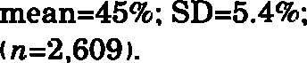
Percent slackmode=50% No slack indicated for 38% of the nets. For nets with slack,
Meshes hanging 60% had 2 and 35% had 1 mesh 42% had 6, 26% had 4, and 17% had 6 meshes hanging hanging between knots tied to the cork between knots tied to the cork line.
Hanging length (cm) mean—50.7; SD—14.6; mode=60.O for mean = 38.4; SD=6.5; mode=38.1 for distance between distance between knots on the cork line. knots on the cork line.
Fishing effort in both fisheries is an unknown quantity and absolute determination is impractical. Consequently, estimates of total fishing effort in each fishery were used to estimate incidental kill. These estimates were based on the combination of observer records, logbook data, and landing receipts. Effort was measured in "effort-days" which was defined as one day of fishing for one vessel. In the driftnet fishery, one effort-day was considered equivalent to setting and retrieving one net, generally 1828.8 m ( 1,000 fm) in length. (One vessel, targeting thresher shark, made two sets per day.) In the setnet fishery, typically two to four net settings, each of about 457.2 m (250 fm) in length, made up one effort-day. Days actually fished was used as the measure of total effort in each fishery because previous exploratory analysis determined that number of days of effort and general location of effort were significant factors in estimation of mortality (Perkins, et al. ⁵ ). For some species, quarter of the year was also determined to be significant. These factors were available for all effort through the California Fish and Game Department and although other approaches to estimation (e.g. a modeling approach) can be developed, the current analysis is based on these factors. Data on other variables, such as total number of nets fished, total length of nets fished, or tons of target fish caught, were not readily available or contained additional variability due to nonsampling errors. Nonsampling errors, those not due to the sampling design, include, but are not limited to
- Effort that is not recorded. This type of error may occur for several reasons, namely the times when no marketable target fish are caught during the entire day of effort and when a log entry is not
Table 2
Observed (obs) and (est) estimated cetacean, pinniped. turtle, and seabird mortality, stratified by year. in the California swordfish and shark drift gillnet fishery during the NMFS Observer Program, July 1990—December 1995. Estimates of total mortality are reported to the nearest individual. Estimated coeffcients of variation (CV) are included in parentheses; (—) indicates CV was undefined. Effort and estimates for 1990 pertain to the third and fourth quarters only.
Year 1990 1991 1992 1993 1994 1995
Estimated days effort 4,078 4,778 4,379 5 442 4 248 3.673
Observed days effort 178 470 596 728 759 572
Percent observer coverage 9.8% 13.6% 13.4% 17.9% 15.6%
Observed trips effort 54 88 97 107 97
 | obs est | CV obs | est | CV obs | est CV | obs est CV | obs est CV | obs est CV
Dall's porpoise 1 23 (0.95) 2 20 (0.67) 1 7 (0.92) 9 67 2 11 (0.64) 1 6 (0.92)
Pacific white-sided dolphin 3 69 (0.56) 5 51 (0.63) 3 22 (0.70) 2 15 (0.66) 3 17 (0.67) 1 6 (0.92) Risso's dolphin o o 5 51 (0.50) 5 37 (0.48) 7 52 (0.51) 1 6 (0.91) 6 39 (0.57)
Bottlenose dolphin o o o o 3 22 (0.93) o
Striped dolphin o o o o o o o o 1
Common dolphin
( unknown stock) 4 92 (0.79) 7 71 (0.70) 5 37 (0.40) 4 30 (0.57) 1
Common dolphin (long beak) o O o O 1 6 (0.91) 6 39 (0.65)
Common dolphin (short beak) 4 92 (0.47) 37 376 (0.21) 39 287 (0.21) 24 179 (0.26) 25 140 (0.18) 36 231 (0.29)
Northern right whale dolphin o o 7 71 (0.41) 2 15 (0.65) 7 52 (0.39) 7 39 (0.42) 9 58 (0.59)
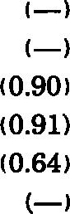
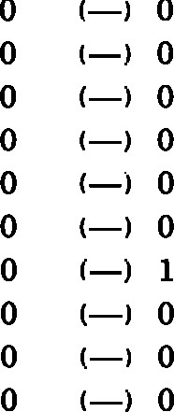
Killer whale O o o O o o o o O o 1 6 (0.92)
Short-finned pilot whale 1 23 (0.95) O O1 7 (0.92) 8 60 (0.54) O oo o
Baird's beaked whale O O o oo o o o
Stejneger's beaked whale o o o o o o
Hubbs' beaked whale o o 3 22 (0.53) o o
Mesoplodont beaked whale 1 23 (0.97) o o1 7 (0.93) o oo oO O
Cuvier's beaked whale o o O6 44 (0.36) 3 22 (0.53) 6 34 (0.36) 5 32 (0.40)
Unidentified beaked whale o O O6 (0.90) O O
Sperm whale o o 1 7 (0.94) 2 15 (0.66) o O
Pygrny sperm whale o o O O 1 7 (0.93) o O
Unidentified Kogia oO1 7 (0.92) o oO O o o
Minke whale oo o o o6 (0.91) o o
Unidentified cetacean o 10 (0.95) 1 7 (0.93) o o o o o o
Unidentified dolphin o 1 7 (0.93) o o
Unidentified whale o 1 7 (0.93) O o
Steller sea lion O 1 7 (0.92) o o 1 6 (0.91) O O
California sea lion 2 46 (0.99) 4 41 (0.58) 9 66 (0.34) 11 82 (0.42) 5 28 (0.40) 4 26 (0.45)
Unidentified sea lion 2 46 (0.97) O o O o o o
Harbor seal 1 23 (0.95) O o o O o o o O
Northern elephant seal 5 115 ( O. 44 ) 13 132 (0.25) 15 110 ( 24 ) 14 105 (0.26) 22 123 (0.23) 14 90 (0.25)
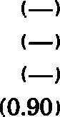
Inggerhead turtle o o o o 1 7 (0.93) o o o o
Leatherback turtle 1 23 (0.97) o2 15 (0.65) 2 15 (0.66) o o4 26 (0.55)
Unidentified turtle o o o o 1 7 (0.93) o O Seabirds (all unidentified) 1 23 (0.98) o O O o o 1
made. The occurrence of this type of error implies that estimates of mortality are biased lower than actual mortality levels.
- Incorrect reporting of effort location by fishermen. This type of error may bias estimated mortality either higher or lower.
- Underestimation of effort from landing receipts. This type of error may occur when a landing receipt, in absence of additional information, is assumed to represent one effort-day (default-value).
A reliable determination of the magnitude of bias these errors cause in estimates of mortality rates has not been made; however, their characteristics indicate that estimates of mortality may be lower than actual values.
Once quarterly effort data were collected, computer programs developed by CDFG were used to assign target species to landing receipts on the basis of information provided by logbooks and observations (Beeson and Hanan⁹). Landing data were then confirmed or modified on the basis of logbook and observer data for the same target species, date, and vessel number. After all three data sources were compared, a day of effort was tallied for each record with a logbook entry or observer record. Landing receipts without corresponding logbook or observer entries three days before and after the receipt date were assumed to represent one day of effort. The numbers of days fished in each CDFG block were then tallied and the resultant data represented estimated total effort. Total effort was estimated quarterly and yearly. Delayed submission of data to CDFG was the primary reason that estimates of yearly effort differed from the sum of the quarterly estimates of effort.
⁹ Beeson, M., and D. Hanan. 1996. Manuscript submitted to California Fish and Game. [Available from the authors at California Department of Fish and Game, 330 Golden Shore, Suite
50. Long Beach, CA 90802.]
Table 3
Observed (obs) and estimated (est) cetacean, pinniped. turtle, and seabird entanglement, stratified by year, in the California swordfish and shark drift gillnet fishery during the NMFS Observer Program, July 1990—December 1995. Estimates of entanglement are reported to the nearest individual. Estimated coefficients of variation (CV) are included in parentheses; (—) indicates CV was undefined. Effort and estimates for 1990 pertain to the third and fourth quarters only.
Year 1990 1991 1992 1993 1994 1995
 | obs est | obs | est | obs | est | obs | est CV | obs est CV | obs est CV
Common dolphin
(unknown stock) 4 92 (0.79) 7 71 (0.70) 6 44 (0.36) 4 30 (0.57) 1
Cuvier's beaked whale o o 6 44 (0.36) 3 22 (0.53) 6 34 (0.36) 6 39 (0.36)
Sperm whale O o 3 22 (0.94) 3 22 (0.69) o o
Humpback whale o o o O 1
California sea lion 2 46 (0.99) 4 41 (0.58) 9 66 (0.34) 12 90 (0.39) 5 28 (0.40) 5 32 (0.40)
Unidentified sea lion 2 46 (0.97) 1 10 (0.95) o o o o o O
Loggerhead turtle O o o o 2 15 (0.66) 5 37 (0.49) o O
Leatherback turtle 1 23 (0.97 ) 1 10 (0.94) 4 29 (0.46) 3 22 (0.53) 1 6 (0.91) 5 32 (0.47)
Unidentified turtle O O o 3 22 (0.93) O o
Seabirds (all unidentified) 1 23 (0.98) o 7 (0.93) o o 1

Mortality estimation
Sampling design The NMFS observer program began in July 1990. Initially, the plan was to sample every fifth trip made by a drift gillnet vessel according to an assignment schedule. The order in which vessels with MMPA exemption certificates were scheduled to be observed was randomly selected. It became evident during the 1990 season that this scheme would not work because of logistical difficulties in adhering to the sampling plan.
Beginning in January 1991, gillnet vessel trips were selected according to the targeted coverage rate (20%), the availability of observer personnel, call-ins (fishermen called in prior to departure), and the ability to notify fishermen of their obligation to carry an observer. (Occasionally fishermen did not call the Observer Program administrator for possible observer assignment.) In addition, the NMFS Fisheries Observer Branch began monitoring vessel activity (arrivals and departures) to estimate observer coverage for placement purposes. If estimated observer coverage dropped below 20% for a vessel, the owner was notified of the obligation to carry an observer. In the setnet fishery, most fishermen were notified after their nets were set whether they would be required to carry an observer. As the program evolved, setnet fishermen began to expect an observer about every fifth trip.
Mortality estimation in the drift gillnet fishery In the swordfish and shark drift gillnet fishery, vessels made trips lasting from one to about 15 days so that
1

Table 4
Observed (obs) and estimated (est) cetacean. pinniped, turtle, and seabird mortality, stratified by year, in the California halibut and angel shark set gillnet fishery during the NMFS Observer Program. July 1990—December 1995. Estimates of total mortality are reported to the nearest individual. Estimated coeffcients of variation (CV) are included in parentheses: (—) indicates CV was undefined. Effort and estimates for 1990 pertain to the third and fourth quarters only.
Estimated days effort 3,041 7.171 5.577 5,680 1.943 2,257
Observed days effort 158 706 698 875 150
Percent observer coverage 5.2% 9.8% 12.5% 15.4% 7.7% 0%
Observed trips effort 406 2,233 2,123 2,642 547
obs | est CV | obs est CV | obs CV | obs est CV | obs est CV | obs est cv
Harbor porpoise 4 37 (0.56) 5 38 (0.47) 6 48 (0.46) 2 13 (0.64) 14 (0.96) — 14 (0.64)
Common dolphin
( unknown stock ) o O o O 2 15 (0.65) o o O O
Unidentified cetacean o O o o 1 8 (0.92) o o O O
Califomia sea lion 67 867 (0.22) 142 1,842 (0.16) 338 3,418 (0.28) 237 1,942 (0.13) 109 905 (0.15) — 724 (0.08)
Unidentified sea lion 1 23 (0.96) 6 109 (0.53) 7 54 (0.34) O o O O
Harbor seal 30 411 (0.23) 42 601 (0.23) 90 1,204 (0.47) 71 475 (0.13) 23 227 (0.33) — 228 (0.13)
Northern elephant seal 13 119 (0.40) 3 30 (0.55) 7 51 (0.35) 11 70 (0.27) 2 16 (0.66) — 47 (0.29) Unidentified pinniped 2 42 (0.79) 3 30 (0.55) 7 50 (0.39) 7 32 (0.90) 1 8 (0.94) — 17 (0.83)
Sea otter 3 27 (0.53) o oo o o O o o
Green/black turtle o Oo O1 8 (0.92) 1 6 (0.90) o o 2 (0.61)
Loggerhead turtle o oo o1 8 (0.92) o o O O
Leatherback turtle o Oo oo O o o 1 8 (0.94)
Unidentified turtleo Oo o 1 6 (0.90) O O2 (0.61)
Pacific loon o o1 13 (0.94) o o
Common loon o o2 22 (0.68) 1 7 (0.92) O O o o
Unidentified loon 1 23 (0.96) 4 48 (0.48) o o O O o o
Western grebe O o 1 8 (0.92) 3 23 (0.70) 1 6 (0.90) o o2 (0.61) Unidentified grebe O O O o 4 31 (0.92) 1 6 (0.90) O O3 (0.83)
Double-crested cormorant 2 18 (0.93) o O 1 7 (0.92.) O o 1 8 (0.94)
Brandt's cormorant 2 41 (0.78) 36 409 14 279 (0.67) 3 13 (0.64) 2 16 (0.66) — 3 (0.43)
Pelagic cormorant 1 33 (0.98) 1 8 (0.92) O O o o O O
Unidentified corrnorant 9 132 (0.45) 15 450 (0.92) 9 68 (0.30) 5 32 (0.40) O O 10 (0.35)
Common murre 142 1.300 (0.21) 289 2.201 (0.27) 292 2,333 (0.28) 137 879 (0.32) 20 284 (0.29) — 967 (0.32)
Unidentified alcid 1 9 (0.93) O O O O O O O O
Unid. seabird o o 2 22 (0.68) 3 23 (0.53) 1 6 (0.90) O O 3 (0.83)
¹ Estimates for 1995 were based on stratified rates from 1993 results.

when a trip was chosen to be observed, the NMFS technician observed all net pulls during the trip. A single net per day was set at dusk and retrieved before dawn. Net pulls and effort-days were equivalent units for this fishery. For estimation of incidental kill, the collection of observed trips during a year was treated as a random sample (an approximation) and a ratio estimator was used. Trips were treated as sampling units and the number of days per trip was treated as an auxiliary variable. Stratification by quarter of year or set location was not used for yearly estimates because previous exploratory analysis had not found this type of stratification to be significantly
related to incidental kill. Yearly estimates, 1991—95, were calculated for each species observed entangled ("Results" section). Estimates for 1990 correspond only to the last two quarters of that year. Formulae from Cochran (1977) were used for estimating kill rate, F, total incidental kill, , and variances:
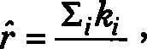 (1) Eidi
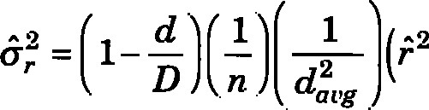r od +0k — 2F&d.k , (2)
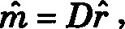 (3)
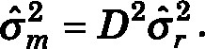 (4)
Variables ki and di represent the observed kill and number of days for the i^{th} trip; daug is the sampled mean number of days per trip; od, Ok , and &d.k are the sample variances and covariance of di and ki ; d and n are the observed number of days and trips, and D represents the total number of days of effort. The finite population correction factor, (1 — n/ N), where N is the total number of trips, was approximated by using (1 — d. / D) because the total number of driftnet trips was not determined during the estimation of effort.
Mortality estimation in the set gillnet fishery In the setnet fishery, a trip was selected and all net pulls during the trip were observed. Because greater than 99% of all observed set gillnet trips were one day in length, a trip was considered equivalent to an effortday. Net pulls were not randomly sampled and total number of net pulls per trip was not recorded for unobserved trips, therefore a trip was considered the sampling unit. For observed trips, the overall average number of net pulls per trip (or effort-day) was 3.08 (CV=O.43), and the overall average number of marine mammal entanglements per trip was 0.48 (CV=3.10) during the NMFS Observer Program.
Table 5
Observed and estimated cetacean, pinniped, turtle, and seabird entanglement, stratified by year, in the California halibut and angel shark set gillnet fishery during the NMFS Observer Program, July 1990—December 1995. Estimates of entanglement are reported to the nearest individual. Estimated coefficients of variation (CV) are included in parentheses, • (—) indicates CV was undefined. Effort and estimates for 1990 pertain to the third and fourth quarters only.
Year |  | 1990 |  | 1991 |  | 1992 |  |  | 1993 |  |  | 1994 19951
Unidentified sea lion  Harbor seal  Unidentified turtle  Common loon  Western grebe  Brandt's cormorant  Unidentified seabird | 67  30  O  O  O  2  O | 867  411  O  O  O  41  O | (0.22)  (0.23)  (0.78) | 143  43  O  4  2  41  2 | 1,850  615  O  48  22  494  22 | (0.16)  (0.23)  (0.60)  (0.68)  (0.37)  (0.68) | 341  90 o 1  3  20  5 | 3,438 1,204  O  7  23  321  37 | (0.28)  (0.47.)  (0.92)  (0.70)  (0.58)  (0.41) | 239  71 2 o 1  5  1 | 1.977 (0.13)  475 (0.13) 13 (0.64) o  6 (0.90)  25 (0.45)  6 (0.90) | 109  23  O  O  O  2  O | 905  227  O O o  16  O | (0.15)  (0.33)  (0.66) | 729  228  5  9  3 | (0.08)  (0.13)  (0.59)  (0.40)  (0.83)
¹ Estimates for 1995 were based on stratified rates from 1993 results.
Researchers had previously shown (Perkins et al.⁵ ) that quarter of year and set location were significant predictors of sea lion and harbor seal entanglement. Consequently, estimation of incidental kill in the setnet fishery was stratified by area for all mammal species. The geographic area fished was divided into four strata: southern California, Channel Islands, Ventura, and central California. Central California included all effort south of Bodega Bay and north of Point Conception, 34⁰30'N (CDFG blocks 437—650). There was no legal coastal setnet fishing north of Bodega Bay. The Channel Islands stratum included all effort within CDFG blocks containing part of any Channel Islands ( CDFG blocks 684—690, 707-713, 760-762, 765, 806-807, 813-814, 829, 849850, and 867). The southern California stratum included all effort south of 33⁰50' N (blocks 718—918), excluding CDFG block 776 and the Channel Islands stratum. The Ventura stratum contained the remaining area. Incidental kill estimation for sea lions and harbor seals included additional stratification by quarter of the year for the southern California and Ventura areas because for these species, overstratification was not a problem.
Yearly estimates ofincidental kill in the setnet fisheries were calculated for all species of marine mammals observed entangled (Tables 4 and 5). Estimates for turtles and seabirds were calculated by the same method. For each species, kill rate, rs, and total incidental kill, ms, were estimated for each area by using a mean-per-unit (MPU) estimator with effortdays as the sampling unit (Diamond and Hanan ^{l} ). Formulae for MPU estimators and their estimated variances for each area are (Cochran, 1977)
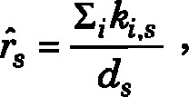 (5)
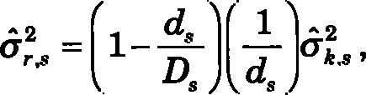 (6)
is = Dis , (7)
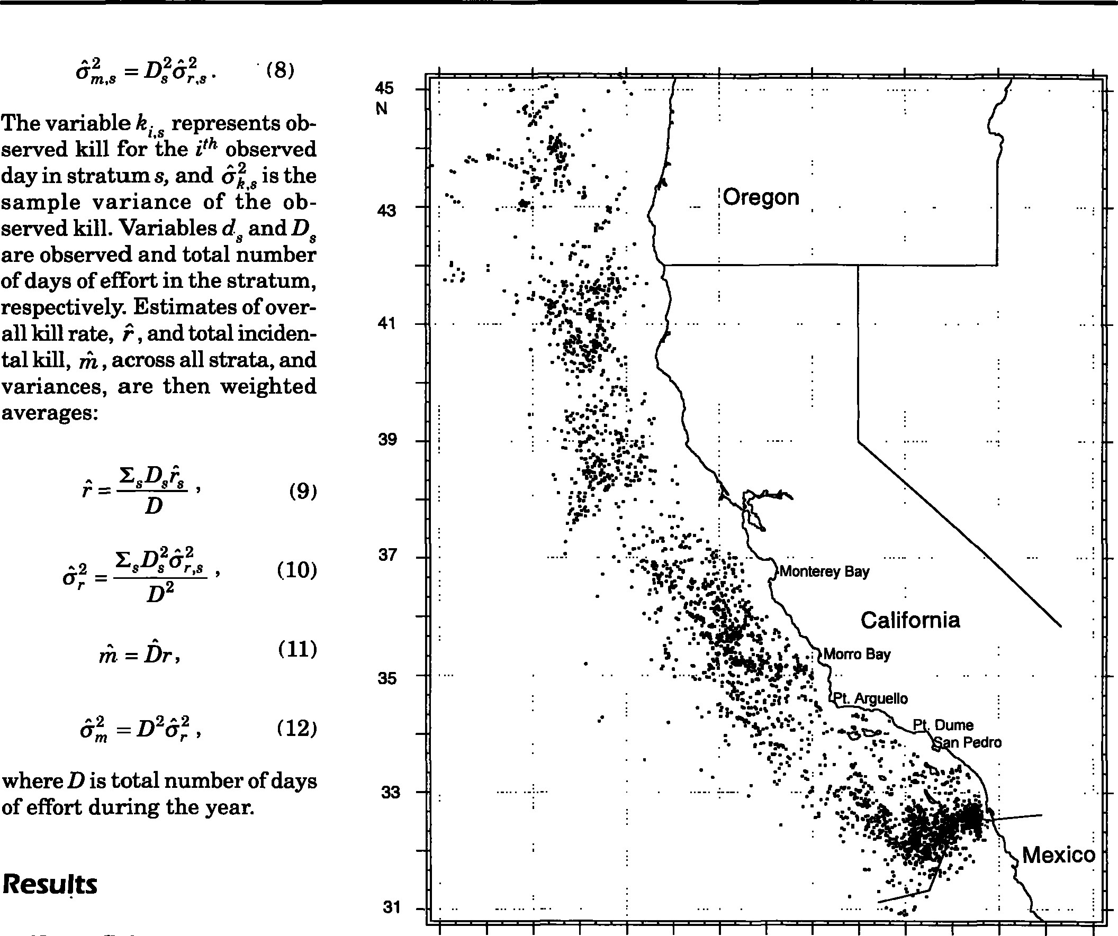
(8)
45 The variable ki s represents observed kill for the i^{th} observed day in stratum s, and 6k s is the sample variance of the ob- 43 served kill. Variables d.s and D are observed and total number of days of effort in the stratum, respectively. Estimates of over-
41 all kill rate, .9 , and total incidental kill, , across all strata, and variances, are then weighted averages:
39
(9)
37
(10)
35
where D is total number of days 33 of effort during the year.
Results
31 Driftnet fishery
During the observed period, the driftnet fishery was subject to area and time restrictions inside 370.4 km (200 nautical miles [n mil) for effort that took
129 126 123 120

Figure 1
Approximate location of observed sets in the driftnet fishery during the period July 1990-December 1995.

place largely (80% of seasonal effort) from 15 August to 31 January. Between 1 February and 30 April, fishing effort was restricted to locations farther than 370.4 km offshore. From 1 May through 14 August (15 July for 1990—92) effort was required to be located farther than 138.9 km (75 n mi) offshore. For the remainder of the year, fishing was allowed within 138.9 km of shore. Since the beginning of the NMFS observer program in 1990, estimated total effort-days for the fourth quarter increased each year except for 1994. Combined effort for third and fourth quarters was consistently over 3,500 sets each year (Table 2). Even though there was effort along the entire California coast, the highest concentration of observed sets was south of 33⁰N (Fig. 1). Observer coverage in this fishery typically ranged between 10% and 15% of estimated total yearly effort for most areas and quarters. (Exceptions as low as 2% and as high as 25% were noted for some quarters and areas.) Bias of a ratio estimate is typically a problem in the case of small sample sizes such as may occur in a perfishing block situation. Because sample size was generally quite large and stratification was not used, estimates were not corrected for bias. During the study period, July 1990—December 1995, nine (2%) of the 472 marine mammals observed entangled were released alive (one unidentified sea lion, one common dolphin, Delphinus spp., two California sea lions, one humpback whale, Megaptera novaeangliae, one Cuvier's beaked whale, Ziphius cavirostris, and

also had 10% of the observed

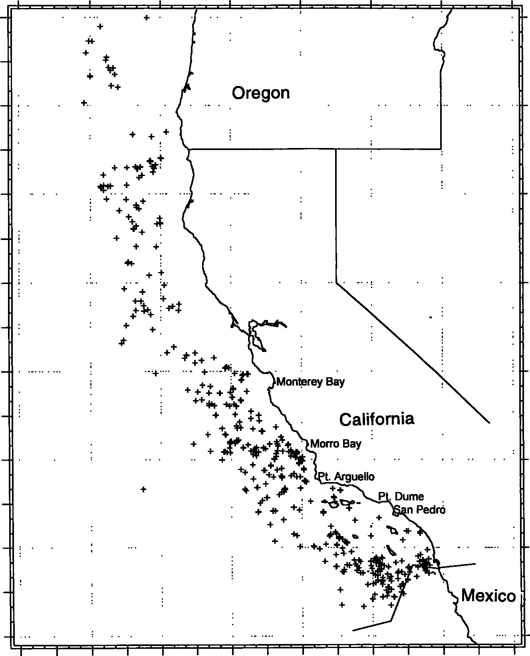
45 mammal bycatch. Locations of marine mammal mortality from observer records indicate that mortality was concentrated in areas of heavy effort but geographically unrestricted (Figs. 1— 2). On a quarterly basis, observed mammal bycatch and swordfish
41catch were correlated (r=O.8), but on a per set basis this correlation was not evident (r=O.O). This change in correlation is perhaps due to the inclusion of substan-
39
tial effort (quarterly) versus per set consideration, i.e. both catch and bycatch are related to effort. Observed seabird mortality
37was very low in the driftnet fishery (three kills observed during the period). Marine turtle entanglement was more common, with 25 observed (13 released
35alive). All but one of the 15 leatherback entanglements occurred north of 35⁰N latitude. Estimated turtle entanglement increased
33from 23 for 1990 to 81 for 1993 and then fell to 32 for 1995.
Setnet fishery
31
Mortality estimates in the setnet fishery pertain to fishing effort
129 126 123 120 11M
targeting halibut or angel shark. Figure 2 By law, effort targeting these spe-

location of observed incidental marine mammal kills in the driftnet cies required gillnets with Approximate fishery during the period July 1990—December 1995, all species. stretched mesh sizes of 21.6 cm (8.5 inches) or greater. This resulted in the elimination of 665

three sperm whales, Physeter macrocepha.lus). Observed mammal bycatch in this fishery consisted predominantly of common dolphins (196). Northern elephant seals, Mirounga angustirostris, were the second most commonly entangled mammal (83). The wide variety of mammal species incidentally entangled, over 25, is notable.
There was no statistically discernible trend in the estimates of total effort during the study period. Coefficients of variation for estimates of marine mammal incidental kill ranged from 0.18 to 0.95. The highest observed incidental kill in a single CDFG fishing block was in block 918, the southernmost block, which had 10% of the total observed mammal bycatch. Waters off central California west of 122⁰W longitude out of 8,614 observer records (net pulls) with mesh size less than 21.6 cm from the original data because they pertained to effort in another fishery. There were an additional 179 observed net pulls with no position data. This effort was assigned to geographic strata based on the specific vessel's known fishing grounds or was apportioned out to strata according to fishing effort from NMFS observer records with known positions.
From 1990 through 1993, estimated effort in the halibut and angel shark fishery was fairly stable with heavy setnet fishing effort along the southern California coast up to Pt. Conception (excluding the region from Rocky Pt. to Pt. Dume, where there was no commercial fishing, and an area around Newport

Beach; Fig. 3). There was also effort in the Morro Bay and Monterey Bay areas, as well as in some areas around the Channel Islands. Estimated effort for 1994 decreased sharply because gillnet fishing was banned inside the area within 5.6 km (3 n mi) of shore from Pt. Arguello south to the U.S.-Mexico border. During each year, observed mammal bycatch peaked during the second quarter, as did estimated total effort (Tables 4 and 5). California sea lions were the most frequently killed mammal (899), followed by harbor seals (257 ), northern elephant seals (36), and then harbor porpoises ( 18). Fourteen of the eighteen observed harbor porpoise mortalities occurred in the northern portion of Monterey Bay; three others were observed in the Monterey Bay area, and the remaining mortality was in the Morro Bay area (none was released alive). There were 1,025 seabird mortali- | ties: 1 Pacific loon, Gavia pa.ci.fica, 5 common loon, Gavia immer, 5 unidentified loon, Gavia spp., 6 western grebe, Aechmophorus occidentalis, 5 unidentified grebe, Podiceps spp., 4 double-crested cormorant, Phalacrocorax auritus, 70 Brandt's cormorant, Phalacrocorax penicillatu, 2 pelagic cormorant, Phalacrocoraz pelagicus, 38 unidentified cormorant, Ph.alacrocorax spp., 880 were common murre, Uria aalge, 1 unidentified alcid, Alcid.ae, and 8 unidentified seabirds, Aves. Of the common murre mortalities, 99% occurred north of Pt. Conception—predominantly in the Morro Bay area (Fig. 4). All other bird species were entangled south of Pt. Conception with few (12) exceptions (Tables 4 and 5 The six observed marine turtle kills were separated either in time or location, but four occurred offshore of Ventura. Locations of observer-recorded effort and bycatch indicated that no fished area was
entirely free of mammal mortal-
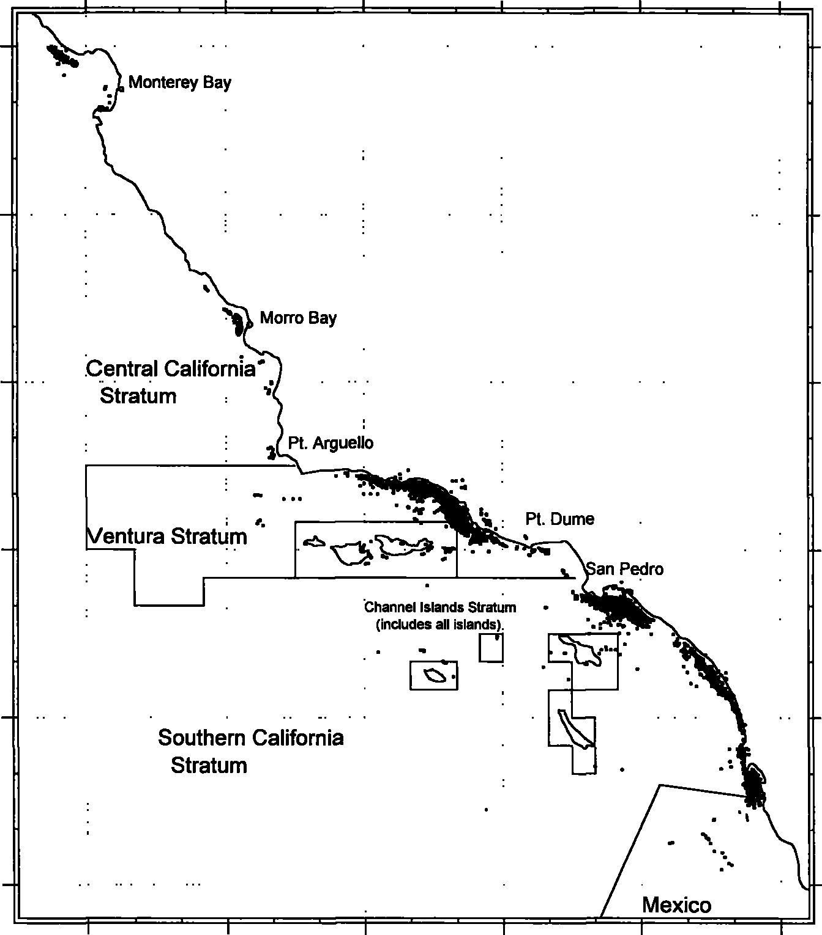
ity due to gillnets (Figs. 3 and
37
5). Estimated total marine mammal mortalities for the setnet fishery rose from approximately 1,500 in 1990, to 4,800 in 1992, and fell to 1,300 in 1994.
36

Discussion
Data collection and effort estimation
35
Although many resources were used to obtain accurate estimates of mortality and fishing effort, several significant diffi-
34culties were encountered in data collection and estimation of total effort. Difficulties in implementing the sampling plan included availability of observers and type of notification
33
given to fishermen. Generally, observers were hired by the Program according to how much fishing effort was expected. Because this aspect of the program was well monitored, little sea-
32 sonal bias was expected. Previous exploratory analysis has in-
122 121 120 119 118 11M dicated that pre- and postnotification is a significant fac-
Figure 3 tor for the setnet fishery (Per-
Approximate location of observed sets in the setnet fishery during the period July kins et al. ⁵ ). In this fishery, out
1990-December 1995. of 2,588 days of observations,
only 74 (3%) were classified as preset notification. In the driftnet fishery, out of 3,338 observations, only 29 were categorized as postset notification. Because these data are so unbalanced in terms of type of notification, further analysis involving type of notification was not pursued. Apart from the overall difficulty of implementing an appropriate sampling plan, perhaps the most common difficulty was with accurate determination of location. Frequently, navigational equipment would not be "working" or was not available to the observer. In some cases, location was incorrectly relayed to the observer and under other circumstances observers were not able to determine location from major landmarks on shore owing to inclement weather. A second difficulty was that observers may not have been able to determine accurately the total number of animals or the species of the animals entangled in gillnets owing to obstruction of view by gear or crew. Also, mammals may have dropped out of a gill net prior to observation. Events of this type were considered nonsampling errors and may have

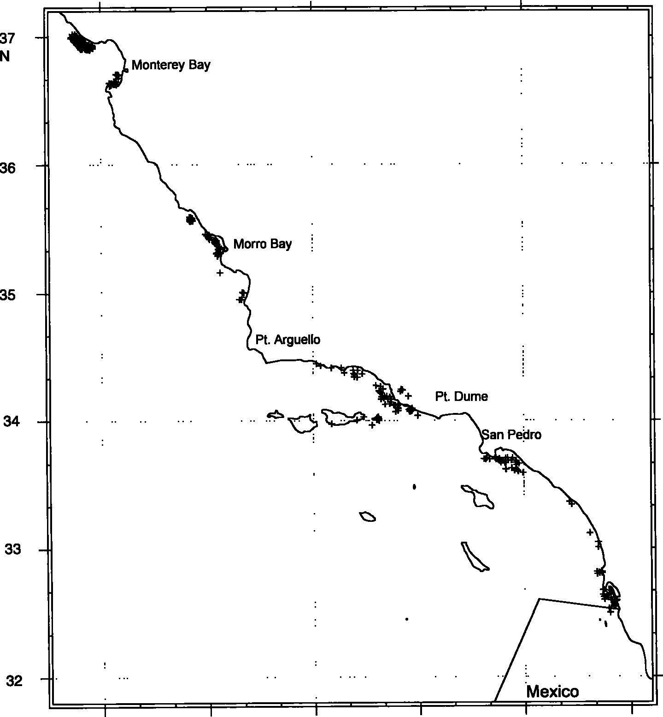
122 | 121 | 120  Figur 4 | 119 | 118
Approximate location of observed incidental seabird kills in the setnet fishery during the period July 1990—December 1995, all species.

biased estimates of incidental kill.
Estimates of total effort were also subject to error, although they were treated as accurate for the purpose of bycatch estimation. They contained inaccuracies due to at least three nonsampling errors:
- Completely unrecorded effort —A typical example of this was when no marketable target fish were caught during a trip and a logbook entry was not made. It was not possible to determine the size of this error; however, given that there were three chances for effort to be monitored (logbooks, observer records, and landing receipts), this error was probably small.
- Absent or imprecise reporting of location—Even though location data were inaccurate, a record of effort was tallied. Thus, because estimates were not stratified by area in the driftnet fishery, this type of error had no impact on the determination of estimates of total effort or mortality for this fishery. (This type of error may be important in more detailed studies.) In the setnet fishery this type of error would not have produced an error in an estimate of total effort but may have produced errors in effort estimates for individual geographic strata. For purposes of mortality estimation, the setnet fishery was divided into four geographic strata, and effort without a recorded location was assigned, with good accuracy, to a stratum based on the vessel's known activity. If no information on a vessel's behavior was known, effort was divided among strata according to the proportion of effort in known locations. No additional error

 | was included in variance estimates because strata | in 1993, the median length of a driftnet trip was 7
 | were large enough and vessels predictable enough | days; the mean was 6.8 (SE=3.3). Consequently, the
 | that "assignment error" was most likely negligible | number of times this approximation occurred was
 | compared with other assumptions. There was no | important. In the setnet fishery, with shorter trips,
 | way to determine accurately the direction of bias | this assumption had less impact. It applied to mul-
 | in effort estimates for each area. | tiple-day trips around the Channel Islands area, off the coast north of Santa Barbara, or when a fish-
3 | Underestimation of effort from landing receipts— | erman held catch for more than one effort-day.
 | Underestimation of effort from landing receipts | Setnet trips were seldom more than a day in length
 | occurred when no effort was logged by fisherrnen | because of catch storage and preservation limita-
 | or recorded by a NMFS observer for three days prior | tions. In both the drift and setnet situations, the
 | and subsequent to the date of the landing receipt. | minimum effort representing a landing receipt was
 | In these cases, a landing receipt was assumed to | used, namely one effort-day, because a more appro-
 | represent one day offishing effort. Ofthe three types | priate approximation would have required a case-
 | of nonsampling errors examined, this was poten- | by-case investigation. The assumption contributed
 | tially significant for the driftnet fishery because trips | toward a possible negative bias of estimates of total
 | in this fishery may last over two weeks. For example, | effort and incidental kill.
 | Combined, these three dif-
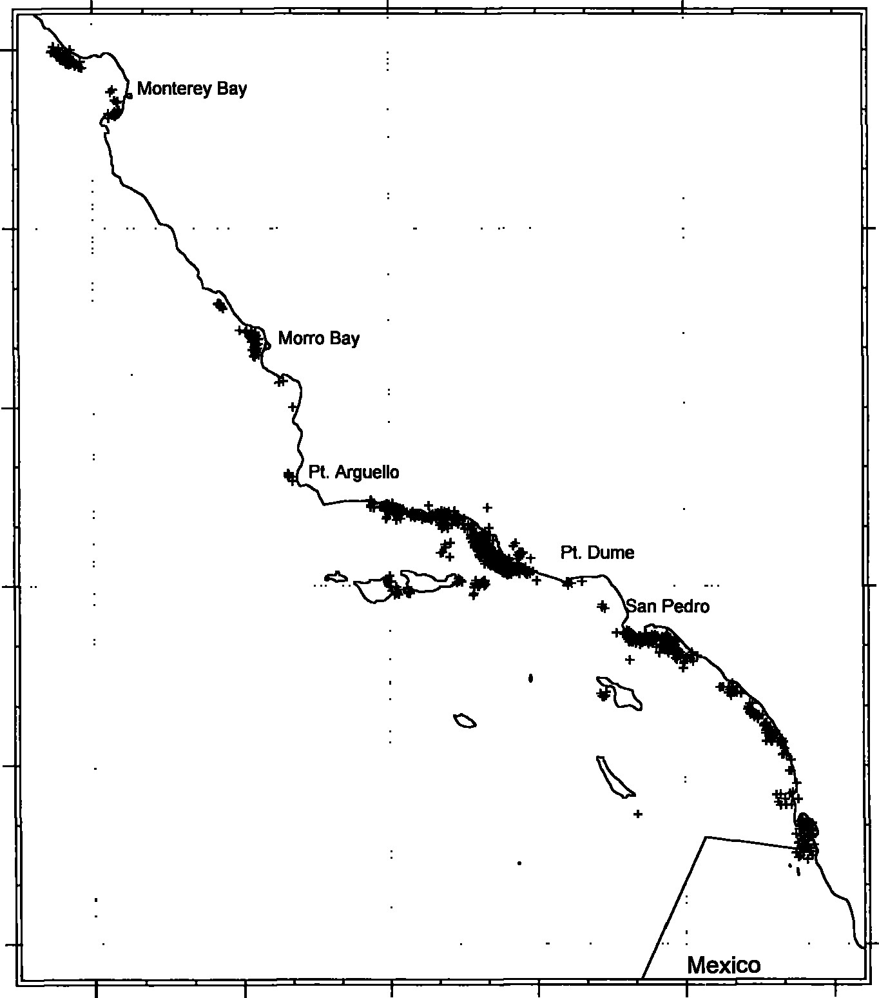
ficulties in estimation of total
37effort may have produced a negative bias in estimates of total effort and, consequently, in estimates of incidental kill (i.e. current estimates of total
36effort may reasonably be considered a minimum). An accurate estimate of bias would be diffcult and costly to obtain.
Mortality
35
Infrequent entanglement of marine mammals, turtles, and seabirds makes accurate estimation of species-specific incidental kill difficult. In 34
spite of our good intentions, estimates may have been confounded by distribution of fishing effort or movement of species. In the future, the
33variability ofestimates can be decreased by more strictly implementing a sampling plan. For some species, a posthoc analysis may be productive as information on
32movement and abundance of stocks becomes available. For
122 121 120 119 118 11M infrequently entangled species, only increased observer
Figure 5 coverage will improve estimaApproximate location of observed incidental marine mammal kills in the setnet fish- tion of incidental entangleery during the period July 1990—December 1995, all species. ment and kill rates.

In the driftnet fishery, the wide variety of cetacean species killed is attributable to the large geographic range of the mammals, nonselectivity of gear, and the amount and location of fishing effort. Cetacean bycatch in the driftnet fishery is greater and more diverse than for the setnet fishery because area of driftnet effort contains more diverse habitat than the area of setnet fishery. Data from recent years show that effort is increasing off the coasts of northern California and Oregon, and beginning in 1995, the state of Oregon allowed 10 driftnet fishing vessels to land fish in a limited number of Oregon ports (landings were not permitted prior to 1995). Yearly effort is expected to continue at 3,500—4,500 sets per year. The mortality rate averaged 0.11 (SD—O.25) mammals/set (or day) during the observer program, from January 1991 through December 1995; initial effort in 1990 was omitted because of low coverage rate. Incidental seabird catch has been almost nonexistent and there is currently no reason to expect an increase. The amount of seabird bycatch contrasts with the Japanese driftnet fishery in which many seabirds are incidentally caught (Ito et al., 1993), in part, because swordfish drift nets are extended below the surface, typically 11 m. The Japanese salmon drift nets, set at the surface, would naturally entangle more seabirds. Migration of seabirds in relation with the fishing season and effort location may play a role in seabird bycatch. No trend is evident in the estimated yearly turtle entanglements. Regarding cetaceans, at this time there are 10 species that are being entangled at a rate greater than potential biological removal (PBR) according to the U.S. Pacific Marine Mammal Stock Assessment Report (Barlow et al., 1995). The impact of driftnet mortality on individual cetacean stocks is examined in this report. In order to reduce entanglement of cetaceans, NMFS, in conjunction with driftnet fishermen and the California Department of Fish and Game, have implemented a Pacific Cetacean Take Reduction Team whose goal is to decrease cetacean bycatch.
Over the past five years, estimated effort in the halibut and angel shark setnet fishery was fairly stable until 1994, when a restrictive California voter proposition banned gillnet fishing within three miles of the coast from Pt. Arguello south to the US-Mexico border. Before 1994, effort in this fishery varied substantially during the year. Since early 1994, gillnet fishing has occurred mainly off Ventura, Morro Bay, and Bodega Bay (Fig. 3). There has also been some effort off Imperial Beach, near the US-Mexico border. Effort north of Pt. Arguello has not been affected by the 1994 resolution and is not expected to change.
Pinniped mortality in the setnet fishery was substantial during 1990—95. More pinnipeds were observed entangled in the setnet fishery than the driftnet fishery because effort coincided substantially with pinniped habitat. In particular, setnet effort around the Channel Islands and near the ports San Pedro, Ventura, and Santa Barbara frequently entangled pinnipeds. Effort in the driftnet fishery results in less overall pinniped entanglement by virtue of this effort being placed farther from shore. It is interesting to note, however, that entanglement of northern elephant seals in the driftnet fishery is substantially greater than for the setnet fishery because these mammals typically range greater distances from shore than do sea lions and harbor seals. Estimates of California sea lion and harbor seal mortality are expected to decline and then stabilize because of reduced effort south of Pt. Arguello.
Similarly, we expect the number of seabirds killed south of Pt. Conception to decline, because setnet effort was been pushed offshore 5.6 km (3 n mi) by regulation. There has been more bycatch of birds in the set fishery because the entangled species are typically resident and their habitat overlaps substantially with setnet effort. Driftnet effort results in few seabird entanglements because drift nets are retrieved after an overnight soak (set nets typically soak 24 hours) and drift nets are typically extended over 11 m below the surface. In addition, mesh size for drift nets is almost three times greater than mesh size for set nets, resulting in fewer entanglements. The mortality of common murres entangled in set nets is expected to continue at the same level. Murre were primarily observed entangled in the Monterey Bay area. The nets in this area are set on the bottom in typically 55.8 m (30.5 fm, SE=O.2 fm) of water. Using a chi-square (X²) test, we determined that there is some dependency between entanglement and soak time of the net (P<O.05). Odds of entanglement more than doubled for an increase from 1 to 2 days of soak time (reasonable checking for confounding factors was done). Turtles will continue to be entangled in the setnet fishery, but the number and rate of entanglement will be unknown because observer coverage in this fishery has been eliminated.

Acknowledgments
Special thanks are given to Al Jackson and Rand Rasmussen of NMFS for assistance with observer data and to NOAA observer-technicians and port coordinators who carry out the California gillnet monitoring programs. Tim Price kindly provided the sampling design description. Jay Barlow, Karin Forney, Doyle Hanan, Mark Lowry, and Peter Perkins reviewed this report and provided valuable input. Helpful and constructive comments were kindly provided by the reviewers. Finally, the cooperation of California gillnet fishermen, who allowed observers access to their boats, is sincerely appreciated.

Literature cited
Barlow, J„ R. W. Baird, J. E. Heyning, K.Wynne, A. M. Manville 11, L. F.Lowry, D. Hanan, J. Sease, and
V. N. Burkanov.
- A review of cetacean and pinniped mortality in coastal fisheries along the west coast of the USA and Canada and the east coast of the Russian Federation. Rep. Int. Whaling Comm., special issue 15:405—426.
Barlow, J., R. L. Brownell, D. P. DeMaster, K. A. Forney, M. S. Lowry, S. Osmek, 'L J., Ragen, R. R. Reeves, R. J. Small.
- U.S. Pacific marine mammal stock assessments.
U.S. Dep. Commer., Southwest Fisheries Science Center Tech. Memo. NOAA-TM-NMFS-SWFSC-219. 162 p.
Cochran, W. G.
1977. Sampling techniques. John Wiley and Sons, New York. NY, 428 p.
Ito, J., W. Shaw, and R. L. Burgner (eds.).
- Symposium on biology, distribution and stock of species caught in the high seas driftnet fisheries in the north Pacific ocean. Int. North Pacific Fisheries Comm., no. 53, vol. 111, 576 P.
Jefferson, T. A., B. E. Curry, and N. A. Black.
- Harbor porpoise mortality in the Monterey Bay halibut gillnet fishery, 1989. Rep. Int. Whaling Comm., special issue 15:445-448.
Lennert, C., S. Cruse, M. Beeson, and J. Barlow.
1994. Estimates of incidental marine mammal bycatch in California fisheries for July through December. 1990. Rep. Int. Whaling Comm., special issue 15:449—461.
Salzman, J. E.
1989. Scientists as advocates: the Point Reyes Bird Observatory and gill netting in central California. Conserv. Biol.

Perkins, P.. J. Barlow, and M. Beeson. 1992. Pinniped and cetacean mortality in California gillnet fisheries: 1991. International Whaling Commission Scientific Committee working paper SC/44/SM14. [Available from Southwest Fisheries Science Center, National Marine Fisheries Service, P.O. Box '271, La Jolla, CA 92038.]
Julian, F. 1993. Pinniped and cetacean mortality in California gillnet fisheries: preliminary estimates for 1992, rev. 2/ 94. International Whaling Commission Scientific Committee working paper SC/45/022. [Available from Southwest Fisheries Science Center, National Marine Fisheries Service. P.O. Box 271. La Jolla, CA 92038.]
Julian, F. 1994. Pinniped and cetacean mortality in California gillnet fisheries: preliminary estimates for 1993. International Whaling Commission Scientific Committee working paper SC/46/011. [Available from Southwest Fisheries Science Center. National Marine Fisheries Service, P.O. Box 271, La Jolla. CA 92038.]
Julian, F. 1995. Cetacean and pinniped mortality in California gillnet fisheries: preliminary estimates for 1994. International Whaling Commission Scientific Committee working paper SC/47/05. [Available from Southwest Fisheries Science Center, National Marine Fisheries Service, P.O. Box 271, La Jolla. CA 92038.]

